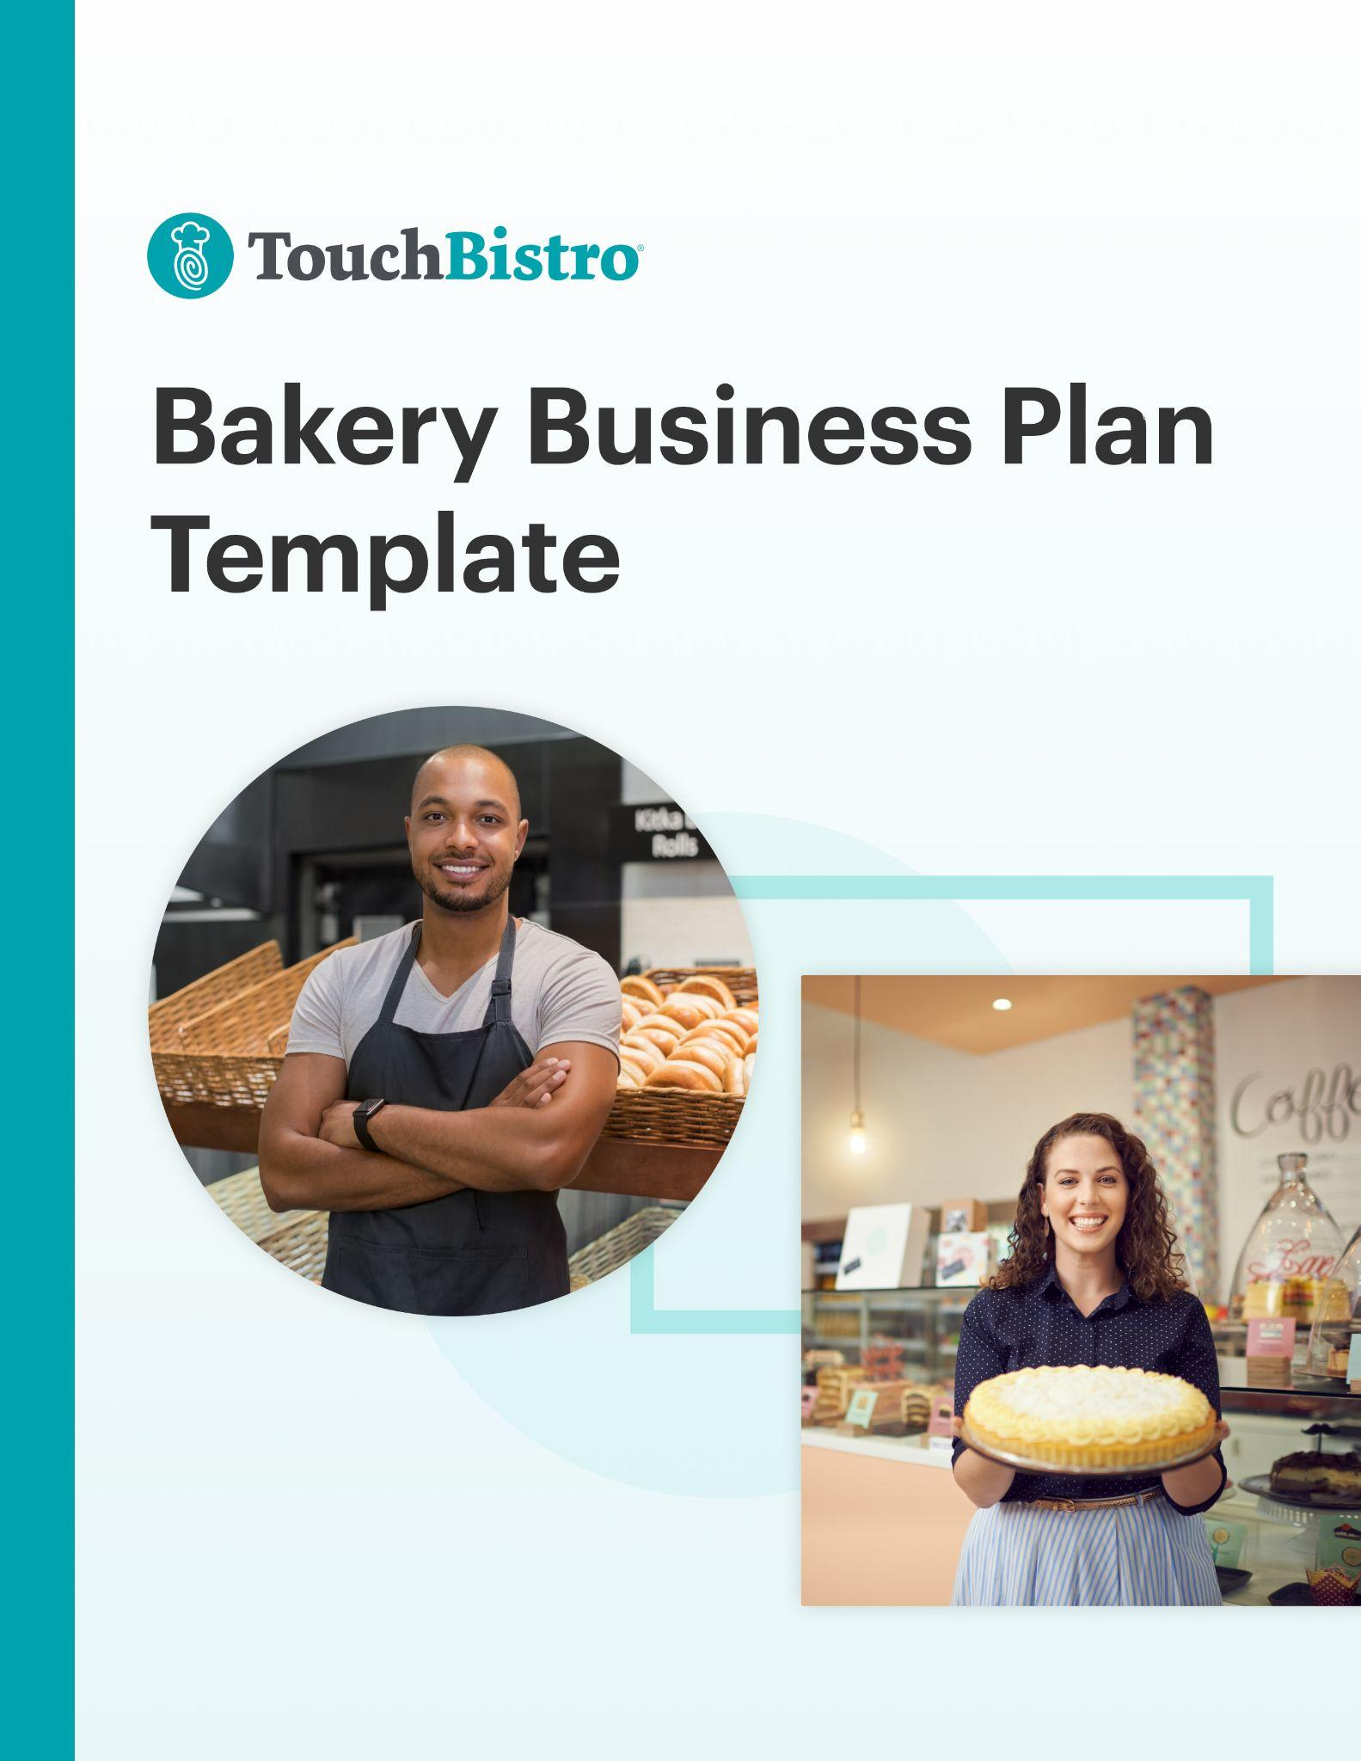

Thank you for downloading TouchBistro’s Bakery Business Plan Template!

This bakery business plan template will help you outline the vision for your new business and share that vision with your investors.

Instructions
This bakery business plan is designed to be fully customized. Under each header, you’ll notice a description for the section in red italics. To customize each section, simply delete the red text and add your own information.

Once you’ve finished filling in each section, delete any remaining red text, as well as the cover page and this instructional page.

To print your template: Click File > Print
To save the template as a PDF: Click File > Save As > PDF

[YOUR COMPANY LOGO]

Business Plan for [NAME OF BAKERY]

ADDRESS
PHONE NUMBER
WEBSITE
EMAIL

Table of Contents

Here you’ll find the outline for each section of your bakery business plan. You can adjust the table of contents as you customize each subsection of your business plan.

Executive Summary

Company Overview

Market Analysis

Business Offerings and Menu

Operations Plan

Marketing and PR Plan

Financial Analysis and Projections

Appendix

Executive Summary

A bakery business plan should always start with an executive summary. This section should summarize your main points, while also inviting the reader (often an investor) to read the rest of your business plan.

This section should also highlight key elements that will be discussed throughout the rest of your business plan, such as:

Business Overview
- Your bakery’s name, concept, and menu items: For example, “Baking Betty’s Bakery is a small, local bakery in New York City that serves cakes, cookies, breads, and pastries, as well as custom-made cupcakes and cakes for special events.”
- Your mission statement and guiding principles.
- Your location and foot traffic: For example, explain if you are in a central location, like if your bakery is located in a busy retail strip or mall. Or, whether the location is easily accessible to the community members that you plan to serve.
- Your bakery service type: Discuss how you will serve baked goods – whether you will erve food directly to your guests’ tables at a sit-down bakery cafe, or whether you will hand customers food from a bakery food truck.
- Your bakery’s ambiance: Describe the atmosphere of your bakery. For example, “Our bakery is homey and comfortable, with couches and armchairs that create a living room-like atmosphere. We also provide magazines, books, and board games so guests will want to stay longer and order more food.”
- Information on the management team: Mention the team’s experience, knowledge of the industry, and understanding of how to run the operational side of the business. If your team has competed in or won any baking contests, you can mention that too.

Success Factors
- Retail space: Make sure to mention if you are in a busy retail space. You can highlight nearby shops, like grocery markets, restaurants, and shopping malls that will bring foot traffic to your bakery.
- Customer Service: Discuss how your customer service will make your bakery stand out. How does your staff stay educated on the latest cake decorating techniques? Is your staff attentive to your guests to help build a loyal customer base?
- Your market position and competitive advantage: Think about what makes your bakery stand out. For example, maybe you’re known for your special butter tart recipe that’s been passed down in your family for generations, adding a great personal story.
- Management experience: Emphasize the years of experience your management team has working in the bakery industry. For example, “Our Founder has 20 years of experience running successful bakery businesses.”

Financial Highlights
- Your financial projections and break even point.
- What funds you need and how you plan to use them to achieve success.
- A summary of potential costs and the expected return on investments.

While it may be tempting to try to include a lot of information right off the bat, try to keep this section to 200-600 words max.

Company Overview
This section is where you fully introduce your new business. The purpose of this section is to provide your reader with a high-level overview of your bakery idea and to answer key questions that investors may have, such as your business history, service type, and ownership structure.

As you fill out each of the sections below, keep in mind that this section can easily come across as a bit dry and mundane. Think about how you can make your business idea stand out with passionate language and captivating details.

Concept
In this section, provide a high-level overview of the concept for your new bakery. While you don’t need to go into too many specifics here, you may want to touch on:

- The defining theme for your bakery
- The drinks and food you plan to offer
- What price point you will serve

Company History
In this section, you will provide a summary of your bakery’s history and why you opened it in the first place. You should also include important details like:

- Your bakery’s legal structure: For example, you can operate as a sole proprietorship, partnership, cooperative, limited liability company, C Corporation, or S corporation.
- Founding team members: You can mention your team’s experience with baking and how they have made a name for themselves by serving up delicious treats over the years.
- Milestones to date: Write about any goals you’ve hit, such as creating a brand image, starting your website, opening your first bakery location, or recruiting key employees.

Service Type
Here you will explain what kind of bakery service type you will be using and why. Every bakery business is different, but here are some of the most popular service types to consider:

- Bakery cafe - A bakery cafe is a sit-down bakery with a dining area for guests to enjoy their food. Opening a bakery cafe requires a back-of-house and front-of-house space.

- Counter service bakery - A counter service bakery has a space for customers to order products, but does not have a dining area, therefore it has lower overhead costs.

- Specialty bakery - A specialty bakery focuses on making a small amount of baked goods. An example is a shop that focuses on making wedding cakes and cupcakes.

Market Analysis

This section is where you describe the specific location of your new bakery and the current market conditions. In addition to general information about your target market, you want to explain your unique positioning in the market, the target audience you’re hoping to appeal to, and how you’ll make your bakery stand out.

Location
Explain the location of your new bakery and why you chose that specific area. If you have not yet chosen a location, describe the town or neighborhood you plan to do business in. For example, mention if your bakery is near a major retail strip that is known for its foot traffic. If your bakery is near a school or office building, you can mention that too.

If you are one of many bakeries in a location, consider pointing out what makes you different, such as your wide variety of specialty baked goods, or your welcoming atmosphere with spacious tables, comfortable chairs, and lots of natural lighting.

Target Market
Describe your target market and your ideal customer profile. Include key information such as market size, demographics, characteristics, and guest behaviors. If you performed any market research before starting your bakery, make sure to include that too. For example, if you found that there are a lot of weddings being booked in your area, the sales potential for specializing in wedding cakes could be very promising.

Market Positioning & Strategy
Here you should describe how you’ll actually reach your target audience. Outline how you’ll position your brand and how you’d like it to be perceived by customers.

Competitive Analysis
In this section, you want to explain the current competitive landscape, as well as your own competitive advantage.

It’s more than likely that there are other bakeries in your area targeting the same demographics, which means you’ll need to explain how you’ll stand out from the competition. The best way to do this is to include a SWOT analysis for your bakery that outlines your business’ strengths and weaknesses, as well as any external opportunities and threats you’d face. This will help investors better understand the specific aspects of your business that will give you a competitive advantage over similar concepts in the area.

Here is a simple example of what your SWOT analysis could look like:
Strengths:
A leadership team with a combined 35+ years of bakery experience.
Weaknesses:
The ramp-up time for new staff could set financial projections back.
Opportunities:
Our location is located in a college district, which would provide a steady flow of foot traffic around breakfast and lunchtime.
Threats:
An established bakery that serves similar baked goods is located in close proximity, which may take away some of our market share.

In your SWOT analysis, remember to not only identify weaknesses and threats, but also how you can overcome them. You want to reassure investors that your business will succeed despite the challenges you’ll face.

Business Offerings and Menu

The Business Offerings and Menu section focuses on the type of baked goods you will offer customers. Discuss every detail about what you plan to sell – whether that’s fresh bread, cookies, cakes, or other baked goods. Make sure to provide an explanation for why you sell these products, and how your delicious treats will bring foot traffic to your bakery.

Remember to avoid industry jargon, buzzwords, or technical knowledge, so someone unfamiliar with your bakery will get excited about your products.

Business Offerings
When you think about your business, what types of products will you be offering your guests? Here are a few questions to help you answer this question:

- Will you be reinventing recipes, or creating brand new products?
- Will you include specialty items like nut-free or custom-made products?
- Where will you source and buy your ingredients and equipment from?
- How do your baked goods compare to others currently on the market?

Sample Menu

Here you’ll want to include a sample menu for your bakery, with separate menus for drinks and other food (if applicable). This section should also include your strategy for menu pricing, menu design, and menu engineering. Here are a few tips:

- Write about the type of baked goods that set you apart. For example, what if, unlike your competitors, you sell gluten-free cupcakes? What if you’re the only bakery on the block to offer key lime pie?
- Explain why you are serving certain baked goods to your target market. For example, tell your reader that you offer a variety of cupcakes with mile-high icing and a cherry on top because you cater to a younger customer base with a sweet tooth. Alternatively, let your reader know if your customer base is more health-conscious, and that’s why you have chosen to serve less indulgent items like low-sugar chocolate chip cookies.
- Think about where your food will be eaten – in-venue or off-premise. For instance, if you’re running a bakery food truck, you might serve students on lunch break, or employees on their way to work. If your customers are on the move, you might consider items like pastries or other small items that can be packaged easily.

Operations Plan

In this section, you need to explain how your bakery will operate day-to-day once you’re up and running. This section should touch on key aspects of your business operations, including your staffing strategies, the technologies and equipment you plan to use, labor and workflows, and your suppliers.

Staffing & Training
Staffing is a major hurdle for just about every bakery. This section should break down your complete staffing strategy, including how you plan to recruit new staff and the hiring criteria for each role. You should also include details about how many people you expect to hire for each role and the approximate pay for each position. For example, will you hire a head baker to lead your team? What about kitchen staff to do food preparation, menu creation, and cleaning?

In addition to hiring, this section should also touch on day-to-day staff management, including how you will handle scheduling, payroll, and labor reporting. If you are hiring a manager to oversee payroll and human resources, be sure to mention this in your Operations Plan.
You may also want to include details about staff training procedures and work safety standards for your bakery.

Technology & Equipment
In this section, provide an overview of key technology you’ll use in your bakery, inventory management software, online ordering system, and more. You should also mention key pieces of specialized equipment you plan to use.

Here are some examples of what to include in this section:

- Equipment like mixers, an oven, a dough proofer, bakeware, or a bread slicer
- Specific arrangements like a baking prep table, counter space, or a display case
- Technology such as a bakery POS to process transactions

Kitchen Layout & Workflow
Here, you’ll want to provide an overview of your kitchen functions, such as your food preparation workflow and full layout of your bakery. This can include your floor plan of your bakery prep area or other visual aids, which you can include here and/or attach in the appendix.

Remember to include retail functions in your workflow such as:

- Order fulfillment processes (for dine-in and pickup): This covers all of your activities involved from the moment a baker receives an order until it is handed out to customers.
- Customer service strategies: These are everyday practices for interacting with customers, like welcoming diners when they walk in, using respectful greetings, and listening intently to what the customer wants.
- Cleaning and maintenance practices: This is how you keep the bakery clean. For example, by mentioning how you keep the counter organized and clutter-free, and how often you clean your coffee machines/equipment.

Inventory & Suppliers
Related to your bakery layout are the operational processes you adhere to, such as your drink/food cost control methods, and inventory suppliers. Provide an overview of the type of vendors you’ll use and how you’ll manage inventory as well as drink/food costs. If applicable, include the cost of using various food and drink vendors.

To help you figure out what vendors and suppliers you use, first think of the inventory items in your bakery. After all, each inventory item had to be sourced from someone or somewhere:

- Products: You may have different types of products like breads, cookies, cakes, pastries, teas and coffees, bottled water, or juices. In addition, you might sell other items like souvenir mugs, thermos containers, or to-go chocolate bars or candy.
- Equipment: To successfully run your bakery, you’ll need to source a variety of equipment that should last for several years to come. For example, this may include mixers, a dough proofer, bread slicers, or a doughnut cake fryer. If you plan to put baked goods on display, then you will need shelving or display cases. Additional equipment may include a stone deck or convection oven, and refrigerators to keep eggs, milk, and cream cool. You will also need a bakery POS as well as a cash drawer to keep track of sales and inventory.
- Additional supplies: Think of your supplies required to serve baked goods to customers, such as plates, paper cups, and takeaway containers for carrying multiple treats. In addition, you might need to source clear plastic cups for cold drinks, lids, napkins, stirrers, straws, or even large containers for group orders.

Marketing and PR Plan
Your marketing plan section details the marketing strategy and tactics you’ll employ to get the word out about your bakery. This section should go into detail about how you plan to market your bakery, both before and after you open.

You’ll describe how you want to drive incoming traffic, in addition to what budget you have in mind, and your expected return on investment. If you have a lot of detailed information, you may want to create a separate marketing plan document.

New to bakery marketing? Download our Ultimate Guide to Restaurant Marketing for some tips you can use.

Promotions Strategy
Your promotions strategy refers to the plan and tactics you will use to increase your bakery product or service demand. It can include the following elements:

Public Relations
Whether you plan to hire a PR firm or do it yourself, here is where you should detail the PR strategy for your bakery. Include any materials you may send to newspapers and other relevant publications, such as a press release about your bakery opening or VIP invites to the soft opening.

Advertising
Here, highlight the different advertising channels you plan to use for your bakery. This can include digital advertising channels such as email marketing and paid search, as well as more traditional advertising tactics like flyers and radio ads.

Social Media
These days, nearly every bakery leverages social media for marketing. Explain how you will use social media to reach your target audience, including which platforms you’ll use (i.e. Facebook, Instagram, etc.), what kind of content you’ll share, and how you’ll build a digital community around your bakery. For example, you can make unique and fun posts about bakery specials, or tease the latest products that are ‘coming soon’.

Referrals
Mention whether you plan to spread the word by asking customers to leave a review. If you’re baked goods speak for themselves, you will likely benefit from this marketing tactic.

SEO Marketing
Do you have a search engine optimization (SEO) strategy in place? This means organizing your website’s content by topics that will improve your search engine results on websites like Google. Keeping your website up-to-date, accessible, and user-friendly will also help improve your SEO.

Community Partnerships
No bakery business operates in a vacuum. Here you should explain any partnerships with influencers or community organizations, in addition to charitable initiatives.

Free Samples
Mention if you will initially give free samples to people visiting your bakery for the first time to let them taste the quality of your baked goods and learn more about what you offer.

Product Strategy
This refers to what beverage and food products you will offer, and how you will stand out from your competitors. For example, will you offer delicious pies, macaron cookies, or cheesecakes?

Pricing Strategy
Here, you’ll discuss your average price point and how it compares to competitive bakeries. For example, will you offer moderate pricing so that customers feel like they’re getting great value when making a purchase at your bakery?

Location Strategy

For this section, explain how your location will impact your bakery’s success. For example, will you use signage, and if so, where will it be placed to attract more customers?

Financial Analysis and Projections

Though your financial analysis is one of the last sections of your business plan, it’s also one of the most important sections. In fact, many investors may skip straight to this section to see a breakdown of your anticipated costs and projected revenue, as well as how you plan to spend their investment.

This section needs to emphasize how your business will grow and be profitable in the long term.

Before finalizing this section, triple-check your projections and consider hiring a financial professional to make sure your numbers are sound.

Startup Costs
In this section, you’ll need to disclose how much money you’ll need to get your business off the ground, including your biggest expenses.

Financing & Loans
Most bakery owners or managers require loans or other sources of funding to get up and running. In this section, detail the types of financing or loans you require to fuel your growth.

Investment Plan
Here, explain the initial investment you are hoping to receive and how you plan to spend it during your first year in business.

Sales Forecast
Your sales forecast should highlight your projected weekly, monthly, and/or annual first-year sales projections. To get this number, you may use different criteria, such as capacity limits, table turn rates, delivery and/or takeout options, menu prices, and more.

Projected Profit & Loss Statement
Use a projected (or pro forma) P&L statement to show how much money you expect to have made (or lost) by the end of your first year in business. This figure should be based on your sales forecast, as well as your projected bakery costs.

Break-Even Analysis
A break-even calculation reveals the amount of revenue needed in order for your bakery to make a profit. You can then compare this number to your sales forecast to determine how long it will take for you to break even so you can let your investors know when they can expect to start seeing an ROI. This takes into account your fixed costs, like payroll, rent, utilities, and drink/food supplies.

Expected Cash Flow
Cash flow is the amount of cash that’s coming in, and going out of your business. For a bakery, this figure will vary based on how often you expect to purchase inventory, the size of your staff, your payroll schedule, and various other factors. In this section, you want to detail your expected cash inflows and outflows for an upcoming period (usually a year).

This section includes projected cash flow statements for all of your kitchen equipment, machinery, labor, and supplies. Consider costs for maintaining your bakery, paying employee wages, baking equipment, and ingredients. Since investors want to know you can handle cash, try to be thorough with monthly projections to prove that you will be able to avoid credit risk.

Appendix

Last but not least is your appendix. While this section is optional, it’s a great place to include charts, plans, graphics, pictures, or any other material investors may find useful. In your appendix, you may want to include:
- A sample menu
- Floor plans for your bakery including your kitchen, storage space, seating area for guests, display table, ordering counter, restrooms, office, and break room for staff.
- Additional financial charts and figures
- Design mockups for your logo, branding, or storefront signage
- Photos of plateware, flatware, and cutlery: Is there anything special about the tableware you use to serve customers?
- Sample images of your color scheme, artwork, or decor: For example, do you have small vases? Candles? Sculptures?
- Mockups of your staff uniform: Are you designing your staff uniform a certain way to reflect your brand image?

