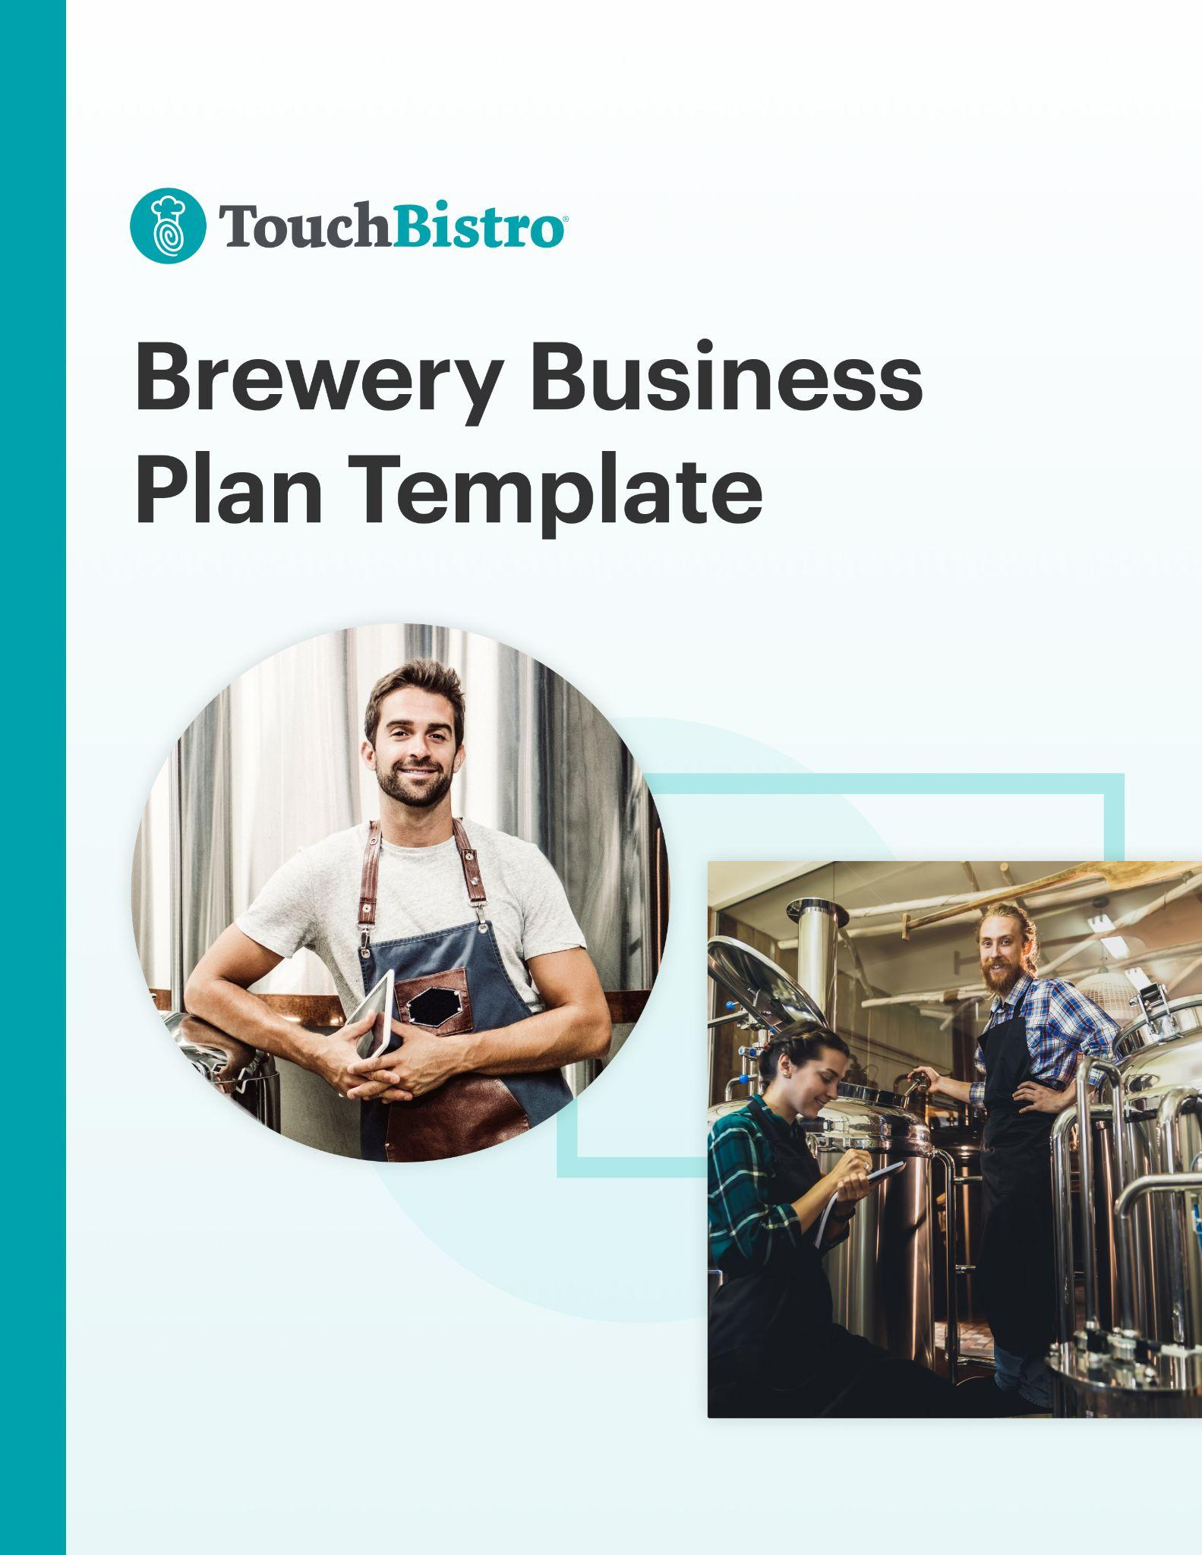

Thank you for downloading TouchBistro’s Brewery Business Plan Template!

This brewery business plan template will help you outline the vision for your new business and share that vision with your investors.

Instructions
This brewery business plan is designed to be fully customized. Under each header, you’ll notice a description for the section in red italics. To customize each section, simply delete the red text and add your own information.

Once you’ve finished filling in each section, delete any remaining red text, as well as the cover page and this instructional page.

To print your template: Click File > Print
To save the template as a PDF: Click File > Sale As > PDF

[YOUR COMPANY LOGO]

Business Plan for [NAME OF BREWERY]

ADDRESS
PHONE NUMBER
WEBSITE
EMAIL

Table of Contents

Here you’ll find the outline for each section of your brewery business plan. You can adjust the table of contents as you customize each subsection of your business plan.

Executive Summary

Business Overview

Business Description

Marketplace Analysis

Marketing and Publicity

Operations Plan

Financial Analysis & Growth Plan

Business Plan Summary

Appendix

Executive Summary

A business plan should always start with an executive summary. This section should summarize your main points, while also inviting the reader (often an investor) to read the rest of your business plan.

This section should also highlight key elements that will be discussed throughout the rest of your business plan, such as:

Business Overview
- Your brewery’s name, concept, and menu items: For example, what drinks and food options do you offer guests, and how is your guest experience unique?
- Your mission statement and guiding principles.
- Your location and food traffic: For example, “Benji’s is a growing brewery in the center of New York City.”
- Your type of brewery: For example, do you run a craft brewery, microbrewery, brewpub or follow another model?
- Your target market: For example, “Our target audience is corporate workers who love a cold pint at the end of a day’s work.”
- Your unique menu: For example, “We serve a wide selection of high-quality ales, pilsners, and lagers.”
- Your brewery’s ambiance: Describe the atmosphere of your brewery. For example, “Comfortable couches and lounge areas surrounded by paintings by local artists, where guests can enjoy a cold beer with friends and family in a home-like setting.”
- Information on your leadership team: Include details about your team’s brewery experience, knowledge of the craft beer industry, and their understanding of how to run the operational side of the business.

Success Factors
- Facility/lease information and your seating capacity: This includes any important information about your venue layout. For example, explain how your patio will contribute to your brewery’s success by providing a comfortable place for guests to enjoy the warm weather.
- Your market position and competitive advantage: Think of what makes your business stand out. For example, “Our market is lucrative and growing with low competition in the brewpub space.”
- Competitor information: Who offers similar beers or guest experiences as your brewery? How will you overcome the competition?
- Management experience: Emphasize the years of experience your management team has working in the brewery industry. For example, Our General Manager has 20 years of experience running successful breweries.”
- Sales and marketing: How will you bring a steady flow of customers to your venue to ensure the success and longevity of your brewery business?

Financial Highlights
- Your financial projections and break-even point.
- What funds you need and how you plan to use them to achieve success.
- A summary of potential costs and the expected return on investments.
While it may be tempting to try to include a lot of information right off the bat, try to keep this section to 200-600 words max.

Business Overview

This section provides a snapshot of your business. The purpose of this section is to provide your reader with a high-level overview of your brewery and to answer key questions that investors may have, such as the brewery type, service model, and ownership structure.

Here are common details you can include that are especially important if you’re seeking loans or presenting to investors for funding:

- Your legal and trade names for your brewery
- Your brewery address (or the general area you plan to operate)
- The date your brewery was founded
- Information about your brewery style: Breweries can be broken down into different types, and each model comes with different limits on what can be used in the brewing process and sold. Here are the most common types of craft brewery models:
  - Microbrewery: Produces less than 15,000 barrels of beer per year and sells 75% or more of its beer off-site.
  - Brewpub: Sells 25% or more of its beer on-site and operates significant food services, usually a restaurant.
  - Taproom Brewery: Sells 25% or more of its beer on-site and does not operate significant food services.
  - Regional Brewery: A brewery that annually produces between 15,000 and 6,000,000 barrels.
- An overview of your service workflow: What are the steps of your workflow – from brewing beer, to breaking down the malt, to serving the final product?
- Your team structure: Who will be on your management team? Who will run the operational business side of your brewery?
- Your founding date and milestones to date: These could be venue-related, like if you finished building a front patio, installed lighting, or finished the interior design. You could also touch upon other business milestones like increased sales, your first repeat customers, putting a scalable marketing strategy in place, gaining recognition in the brewery industry, or hiring and training a talented team.
- Your contact phone number and email address
- Banking details like your branch and banker’s name
- Your brewery’s website and social media links

Business Description

Your business description goes into more detail about your brewery, such as what your service will look like, where you will be located, your menu variety, and the type of atmosphere you plan to create. Overall, this section should highlight your overall brewery concept, vision, and goals for achieving business success.

Here are a few areas you can include in your business description:

Mission Statement
Your mission statement says what your brewery stands for, your beliefs, and what you’re trying to achieve. When writing your mission statement, consider your end goals. For example, “to craft beers of distinct quality and variety, while providing an outstanding level of customer service and support.”

Legal Structure
Consider whether your business will be a partnership, sole proprietorship, or incorporated. Be concise when referring to brewery licenses and laws, and who will be responsible for keeping them at your brewery. Keep in mind, laws vary by location. For example, here are California license types.

Business Objectives
Describe any short or long-term goals that you would want an investor to know. For example, are you considering expanding to multiple locations, or entering into new markets beyond your current target reach? Remember to be concise, and to keep your goals reasonable and achievable.

Location
Describe the neighborhood where your brewery is located, and why it is advantageous. For example, are there few competitors in your area? Perhaps there are many office buildings and construction workers in the area who will visit your brewery? What features will draw visitors to your neighborhood?

Sample Menu
Here, you’ll want to include a sample beer menu for your brewery, with separate menus for non-alcoholic drinks and food (if applicable). Whether you serve food or not will depend on the type of brewery model you operate. For example, a brewpub offers significant food services, while a taproom brewery generally does not offer food.

This section should also include your strategy for menu pricing, menu design, and menu engineering. Here are a few tips:

- Explain what drink and food options you will offer guests, and any catering or additional services. What beers will you have on tap? Will you have meals or snacks, like chips and nachos, for guests to eat?
- Describe why you are serving certain drinks to your target market. For example, tell your reader that you offer specialty beers made with additional spices, flavorings, or fruit to appeal to a younger audience with a sense of adventure to try new drinks
- Think about where your guests will enjoy food and drink – in-venue or off-premise. For instance, if your customers will be hungry, such employees after a long day of work, then consider including food items like pizza or light appetizers such as nachos and wings.

Need help designing a sample menu? Start with one of these free menu templates.

Design & Layout

In this section, you should provide an overview of your brewery design and layout. For example, will your pub have a cottage feel with wooden paneling, or what about a cozy fireplace for guests to have a romantic date night? What aspects of your design will draw visitors to return to your location again and again?

Be sure to touch on how each of these elements complements your brand:

- Your brewery type: Your type of brewery will determine what equipment you will need to include in your design and layout, depending on the amount of beer you will produce.
- Venue signage: What will the outside of your brewery look like? Will you have a memorable sign that stands out and reflects your employees, products, and brand identity?
- Brewery equipment and technology: How have you designed your brewery to fit your brewing equipment? What about your brewery POS?
- Color scheme: Describe the colors of your brewery, your artwork, and wall decor.
- Drinkware, plateware, flatware, and cutlery: Is there anything special about the tableware you use to serve customers?
- Small decor: What about the finishing touches? Do you have small plants? candles? Sculptures?
- Staff uniform: Was your staff uniform designed a certain way to reflect your brand image?

When creating a diagram of your design layout, be sure to include any rooms or elements that are key to your business success and that improve your guest experience, such as:

- Bar area
- Dining area
- Entrance and exit
- Windows and doors
- Brewing facilities
- Fermenting room
- Storage spaces
- Tasting area
- Tables and chairs (be sure to include how many customers can be seated)
- Break room/employee lounge area
- Office space
- Food preparation or kitchen area (if applicable)
- Air conditioning and heating vents
- Restrooms

Marketplace Analysis

As more breweries open up and enter the landscape, it’s important to know how your business compares. This section is where you describe the specific location of your new brewery and the current market conditions. In addition to general information about your target market, you want to explain your unique positioning in the market, the target audience you’re hoping to appeal to, and how you’ll make your brewery stand out.

Location
Explain the location of your new brewry and why you chose that specific area. If you have not yet chosen a location, describe the town or neighborhood you plan to do business in. For example, mention if your brewery is near a major tourist area that is known for its foot traffic. If your brewery is near office buildings, you can mention that too.

If you are one of many breweries in a location, consider pointing out what makes you different, such as your wide variety of brews, or your welcoming atmosphere with spacious tables, comfortable chairs, and lots of natural lighting.

Target Customer

Describe your target market and your ideal customer profile. Include key information such as market size, demographics, characteristics, and guest behaviors. If you performed any market research before starting your brewery, make sure to include that too. For example, if you have data on a high demand for ales, lagers, and pilsners in your location, the sales potential for selling these products could be very promising.

Market Positioning & Strategy
Here you should describe how you’ll actually reach your target audience. Outline how you’ll position your brand and how you’d like it to be perceived by customers.

Industry Trends
Describe any current trends happening in your specific industry. For example, is your craft brewery experiencing any economic or social impacts that have affected your business?

Competitive Analysis
In this section, you want to explain the current competitive landscape, as well as your own competitive advantage.

List who your direct competitors are in your neighborhood. These are breweries that offer similar beers or guest experiences as your venue. Indirect competitors may not be breweries, but are an alternative choice where guests can spend time and money, like a family style restaurant

The best way to compare your brewery to competitors is to include a SWOT analysis that outlines your business’ strengths and weaknesses, as well as any external opportunities and threats you’d face. This will help investors better understand the specific aspects of your business that will give you a competitive advantage over similar concepts in the area.

Here is a simple example of what your SWOT analysis could look like:

Strengths
A leadership team that has a combined 35+ years of brewery experience.

Weaknesses
The ramp-up time for new staff could set financial projections back.

Opportunities
We have a greater menu variety and more interactive brewery tour experiences.

Threats
An established craft brewery that serves similar drinks is located in close proximity, which may take away from our market share.

In your SWOT analysis, remember to not only identify weaknesses and threats, but also how you can overcome them. You want to reassure investors that your business will succeed despite the challenges you’ll face.

Marketing and Publicity

Your marketing plan section details the marketing strategy and tactics you’ll employ to get the word out about your brewery. This section should go into detail about how you plan to market your brewery, both before and after you open. Here are a few sections you should cover:

Product Positioning
Discuss how you will keep your brand top of mind for your consumers. Outline any key differentiators, like what customers can get from your brewery that they can’t get elsewhere.
To figure out your differentiators, ask yourself a few questions:

- What type of beer do you brew?
- What type of guest experience do you offer?
- What makes your brewery unique?

Pricing Strategy
Describe how your pricing compares to competitors. Here are a few questions you can answer in your pricing strategy:

- What are your costs? From materials to labor to packaging.
- What is the market price for similar beers?
- How does your pricing measure up to the market price?
- What do you expect to see in your return on investment?

Remember that your pricing strategy needs to cover the costs of production, and leave room for profit so you can grow your business!

Location Strategy
For this section, explain how your location will impact your brewery’s success. For example, will you offer free beer tastings? How will you attract more local customers?

Promotions Strategy
Your promotions strategy refers to the plan and tactics you will use to increase your brewery product or service demand. It can include the following elements:

Public Relations
Whether you plan to hire a PR firm or do it yourself, here is where you should detail the PR strategy for your brewery. Include any materials you may send to newspapers, magazines, and other relevant publications, such as a press release about your brewery opening or VIP invites to the soft opening.

Advertising
Many consumers decide where they will buy a drink based on ads. This can include digital advertising channels such as email marketing and paid search, as well as more traditional advertising tactics like flyers and radio ads. You can also promote photos to get your beers in front of eyes on Google, Facebook, YouTube, Twitter, Instagram, or even Pinterest.

Social media
These days, nearly every brewery leverages social media for marketing. Explain how you will use social media to reach your target audience, including which platforms you’ll use (i.e. Facebook, Instagram, TikTok, etc.), what kind of content you’ll share, and how you’ll build a digital community around your brewery.

Your website
Optimize your website and ensure that your blog uses SEO tactics to show up on Google keyword searches. The content on your brewery’s website should be full of useful content, and your menu should be easy to find from your main homepage. You can also ask guests for their emails to build a newsletter list.

Community Partnerships
No brewery operates in a vacuum. Here you should explain any partnerships with influencers or community organizations, in addition to charitable initiatives.

Free Samples
Mention if you will initially give free craft beer samples to people visiting your brewery for the first time to let them taste the quality of your drinks and learn more about what you offer.

Operations Plan

In this section, you need to explain how your brewery will operate on a day-to-day basis once you’re up and running. This section should touch on key aspects of your business operations, including your staffing strategies, suppliers, insurance, licensing, technology, and workflow.

Here are a few elements you should cover in your Operations Plan:

Staffing & Training
Identify the core members of your management team and other staff. You can include their years of experience, qualifications, and responsibilities. Be sure to outline how each person on your team will help you run the brewery efficiently.

Staffing is a major hurdle for just about every brewery. This section should break down your complete staffing strategy, including how you plan to recruit new staff and the hiring criteria for each role. You should also include details about how many people you expect to hire for each role and the approximate pay for each position. For example, will you hire a master brewer to run your equipment? What about staff to pour drinks, serve food, and clean your venue?

In addition to hiring, this section should also touch on day-to-day staff management, including how you will handle scheduling, payroll, and labor reporting. If you are hiring a manager to oversee payroll and human resources, be sure to mention this in your Operations Plan.
You may also want to include details about staff training procedures and work safety standards for your brewery.

Technology & Equipment
In this section, provide an overview of key technology you’ll use in your brewery, inventory management software, online ordering system, and more. You should also mention key pieces of specialized equipment you plan to use.

Here are some examples of what to include in this section:

- Brewery equipment like a grain mill, fermentation systems, and more
- Specific arrangements like tap beer towers, counter space, or a display case
- A brewery POS like TouchBistro with an inventory integration like BevCheck.

Brewery Layout & Workflow
Here, you’ll want to provide an overview of your drink preparation workflow and layout of your brewery. This can include your floor plan of your brewery or other visual aids. You can include these assets here and/or attach them in the appendix.

Remember to include business functions in your workflow such as:
- Order fulfillment processes (for dine-in and pickup): This covers all of your activities involved from the moment a server receives an order until it is handed out to customers.
- Customer service strategies: These are everyday practices for interacting with customers, like welcoming guests when they walk in, using respectful greetings, and listening intently to what the customer wants.
- Cleaning and maintenance practices: This is how you keep the brewery clean. For example, by mentioning how you keep the bar area organized and clutter-free, and how often you clean your brewery equipment.

Inventory & Suppliers
Related to your brewery layout are the operational processes you adhere to, such as your drink/food cost control methods, and inventory suppliers. Provide an overview of the type of vendors you’ll use and how you’ll manage inventory as well as food/drink costs. If applicable, include the cost of using various food and drink vendors.

To help you figure out what vendors and suppliers you use, first think of the inventory items in your brewery. After all, each inventory item had to be sourced from someone or somewhere:
- Products: You may have products like different types of ales, lagers, and pilsners. In addition, you might sell other items like glassware, branded apparel, coasters, and other accessories, like keychains, beer holders, and bottle openers.
- Equipment: To successfully run your brewery, you’ll need to source a variety of equipment that should last for several years to come. For example, this may include brewing units, fermentation units, temperature controlling units, and more. You will also need a brewery POS to keep track of sales, orders, and inventory.
- Additional supplies: Think of your supplies required to serve beer to customers, such as beer mugs, goblets, pilsner glasses, steins, or other traditional glassware. In addition, you might need to source clear plastic cups for cold drinks, lids, napkins, stirrers, straws, or even large containers for group orders.

Insurance Plan
Include your insurance provider and plan information. Without insurance, you’re risking the chance of having to close your brewery in the case of an unexpected injury or equipment failure.

Licenses
List any business license or other permits that you have attained. For more information, ask your local government about required licenses and permits in your venue’s location. This is especially important if you also plan to sell food at your brewery.

Financial Analysis & Growth Plan

Though your financial analysis is one of the last sections of your business plan, it’s also one of the most important sections. In fact, many investors may skip straight to this section to see a breakdown of your anticipated costs and projected revenue, as well as how you plan to spend their investment.

This section needs to emphasize how your business will grow and be profitable in the long term. Triple-check your projections and consider hiring a financial professional to make sure your numbers are sound.

Startup Costs
In this section, you’ll need to disclose how much money you’ll need to get your business off the ground, including your biggest expenses.

Financing & Loans
Most brewery owners or managers require loans or other sources of funding to get up and running. In this section, detail the types of financing or loans you require to fuel your growth.

Investment Plan
Here, explain the initial investment you are hoping to receive and how you plan to spend it during your first year in business.

Sales Forecast
Your sales forecast should highlight your projected weekly, monthly, and/or annual first-year sales projections. To get this number, you may use different criteria, such as capacity limits, table turn rates, delivery and/or takeout options, menu prices, and more.

Projected Profit & Loss Statement
Use a projected (or pro forma) P&L statement to show how much money you expect to have made (or lost) by the end of your first year in business. This figure should be based on your sales forecast, as well as your projected coffee shop costs.

Break-Even Analysis
A break-even calculation reveals the amount of revenue needed in order for your coffee shop to make a profit. You can then compare this number to your sales forecast to determine how long it will take for you to break even so you can let your investors know when they can expect to start seeing an ROI. This takes into account your fixed costs, like payroll, rent, utilities, and drink/food supplies.

Expected Cash Flow
Cash flow is the amount of cash that’s coming in, and going out of your business. For a brewery, this figure will vary based on how much beer you produce and sell, the size of your staff, your payroll schedule, and various other factors. In this section, you want to detail your expected cash inflows and outflows for an upcoming period (usually a year).

This section includes projected cash flow statements for all of your brewery equipment, machinery, labor, and supplies. Consider costs for maintaining your brewery, paying employee wages, brewing units, and ingredients like hops, barley, and yeast. Since investors want to know you can handle cash, try to be thorough with monthly projections to prove that you will be able to avoid credit risk.

To keep track of financial information more accurately, you can use accounting software that integrates directly with your POS such as MarginEdge, Xero, Sage, QuickBooks, or Shogo.

Business Plan Summary

This section should highlight the strongest points of your business plan to tell your brewery’s powerful story. This section should ultimately show your reader why your brewery is unique and worthy of investment. It should also describe how your business will grow and achieve financial profitability. Make sure to include:

- What you require to succeed, such as loans or an advisor
- How your brewery is special compared to your competitors
- A few sentences to thank your readers for their time and interest

Appendix

Last but not least is your appendix. While this section is optional, it’s a great place to include charts, plans, graphics, pictures, or any other material investors may find useful. In your appendix, you may want to include:
- A sample menu
- Floor plans for your dining room and/or kitchen
- Additional financial charts and figures
- Design mockups

Best of all, this free brewery business plan is easy to save and share. Save the file in the word processing program of your choice – Pages or Word – and then print it or share it digitally with friends, family, and investors.

If you’re ready to bring your brewery dreams to life, this business plan template is the best place to start.

