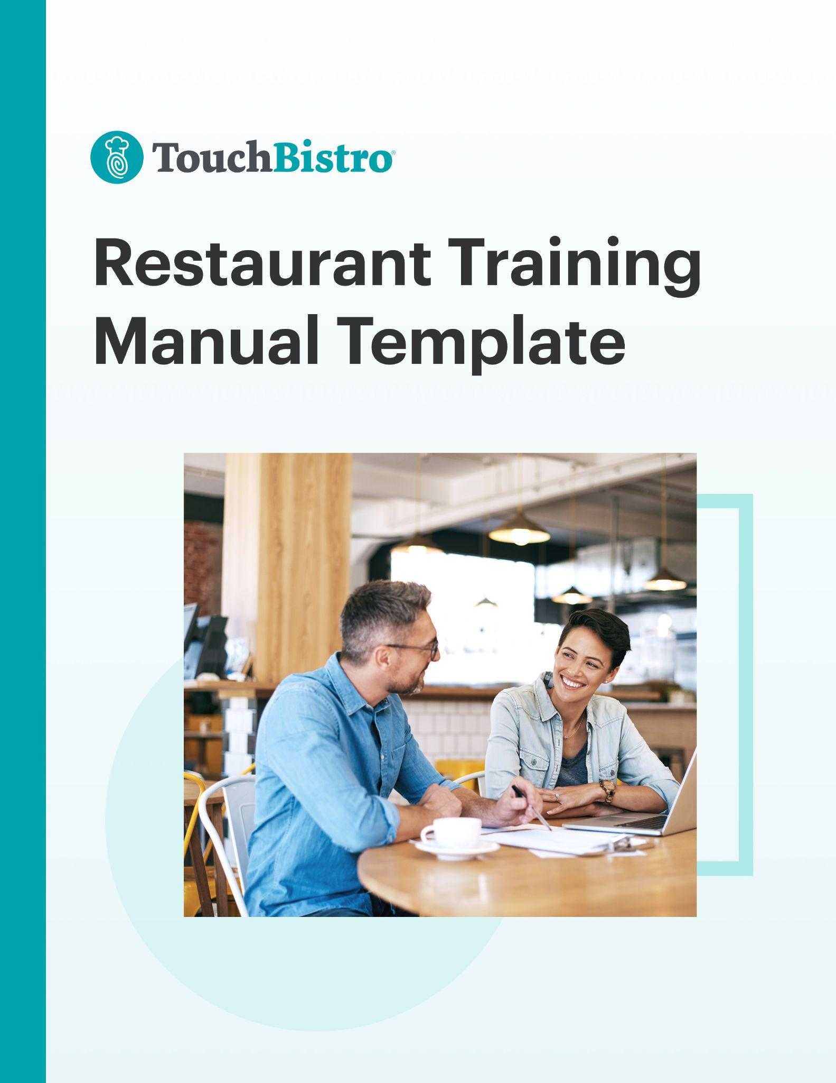

Thank you for downloading TouchBistro’s Restaurant Training Manual Template!

This restaurant training manual template will help you write a guide that employees can use to understand all of the rules and processes for working at your restaurant.

Instructions
This restaurant training manual is designed to be fully customized. Under each header, you’ll notice a description for the section in red italics. To customize each section, simply delete the red text and add your own information.

Once you’ve finished filling in each section, delete any remaining red text, as well as the cover page and this instructional page.

To print your template: Click File > Print
To save the template as a PDF: Click File > Save As > PDF

[YOUR COMPANY LOGO]

Restaurant Training Manual for [NAME OF RESTAURANT]

ADDRESS
PHONE NUMBER
WEBSITE
EMAIL

Table of Contents

Here you’ll find the outline for each section of your restaurant training manual. You can adjust the table of contents as you customize each subsection of your training manual.

Introduction

Training

Roles & Responsibilities

Technology

Health & Safety

Conclusion

Appendix

Introduction

A restaurant training manual should always start with an introduction. This section should give a general overview of your restaurant and invite staff to keep reading through your entire document. Consider the following key elements to include:

Welcome to the Team!
Greet new employees with a personalized letter from a lead staff member. This is a great opportunity to express appreciation and say why you’re excited for new hires to join your team.

About the Restaurant
Provide a brief overview of the history of your restaurant’s founding, including:
- When, why, and how your restaurant was started
- A brief description of the founder(s)
- Major turning points or events in your company’s history

Our Mission
State your mission statement to tell employees what your restaurant does and why you run your restaurant everyday. For instance, Sweetgreen’s mission statement is “Building healthier communities by connecting people to real food.”

Company Values
Present an overview of your core company values. Ensure they’re easy to understand so everyone can uphold your brand image. For example, Panda Express' core values are Proactive, Respect/Win-Win, Growth, Great Operations, and Giving.

Guest Experience
Explain how employees contribute to your overall guest experience. Consider including best practices and tips on how to:
- Greet and speak appropriately to guests
- Be attentive and resolve guest concerns
- Support or help run special events

Training

This section should outline details about your training program and why it exists. Consider the following key elements to include:

Value of Training
Explain the significance of your overall training experience and how it benefits guests and staff. Some new hires might not understand why they need to retrain after working at other restaurants, so use this section to clearly show them why your training is valuable.

For example, outline how your training helps ensure a standout customer experience. You can also describe the benefits of any classes or certifications, like obtaining a food handlers permit.

Expectations
Explain your expectations of an employee who has completed training. What will they be responsible for? You can write your expectations in a list. For example:

Expectation 1: You will have completed and passed the mandatory training certification.
Expectation 2: You will be responsible for taking orders and serving food to customers.
Expectation 3: You will report any health or safety hazards immediately to your supervisor.

Timeline
Provide a timeline for new hires to complete their training – whether it’s a week crash course or a 30-day training period. Place each task in a list, along with its start and end date so employees know what to expect.

Health & Safety
Hygiene policies are important to keep the restaurant environment safe, and to reassure staff and guests that you have their best interests at heart. Consider answering these questions:
- How will health and safety be included in staff training?
- What protocols must be followed on a day-to-day basis?
- What certifications or classes should be completed?

Role & Responsibilities
Now that you’ve built some excitement around your brand, it’s time to break down employee roles and responsibilities by team. This section is also a great opportunity to set expectations and let staff know how they’ll be evaluated.

As a bonus, consider adding visuals to this section, like role-specific imagery, a map, or workflow that walks your reader through their responsibilities.

About Your Role
Describe the responsibilities of each role in a conversational language, as if you’re talking in person. Explain to whom the employee will be reporting and why the new hire’s position is important to your business.

Role Responsibilities
Create an overview of responsibilities for the role. For example, here’s a list of some responsibilities for a restaurant server:

Responsibility 1: Greeting customers when they arrive at the restaurant.
Responsibility 2: Providing exceptional customer service during the dining experience.
Responsibility 3: Carrying drinks and food from the kitchen to the tables.

Evaluation Process
Explain how a manager will evaluate an employee’s work during a performance review. For example, will your employee evaluation form assess behaviors, like “teamwork and collaboration,” or will you use measurable results, like “punctual to work 80% of the time.”

Front of House Procedures
If your new hire is working in the front of house, you should provide a clear outline on how they should interact with guests. Consider adding the following key elements:

Greeting Guests
What are the guidelines around welcoming guests and showing them to their table? How fast should guests be seated after arrival?

Table Check-Ins
How frequently should a server check-in on guests? For example, should they check-in every 10 minutes?

Order Taking Process
Explain how servers should take orders from guests. To get started, try to answer the following:
- How quickly should servers ask diners if they want a drink after they are seated?
- Should servers write orders down on a notepad, or enter them into a handheld POS?
- Should servers find out what a guest likes and make suggestions accordingly?
- Do servers need to confirm guests orders are correct using a POS equipped with tableside ordering?
- How should servers communicate orders with the kitchen? For example, will orders punched into the POS sync directly to your kitchen display system?
- Should main courses be presented at the same time as appetizers?

Menu Knowledge
How should servers learn about guest preferences or allergies, and make recommendations from the menu? Does your POS alert servers when certain items are out of stock? Should they mention your daily food and beverage specials?

Server Responsibilities
Document any processes for handing guests their food, or any special arrangements between runners, servers, and the kitchen.

Clearing The Table
Identify who is responsible for clearing tables and what the next steps are after guests finish
their meal. For example, should a server ask about dessert before giving out the check, or should they suggest a gift card purchase for future use?

How to Close Out a Tab
Explain how to present the bill for a tab, whether to charge the guests’ credit card, and how to make changes. You can also let the server know how to apply restaurant gift cards.

Guest Departure
Tell your staff how they should bid guests farewell when they are ready to leave, such as with a warm “Goodbye” or a friendly “See you again soon.”

Resetting the Table
Lay out your restaurant’s guidelines for resetting the table between seatings. For example:
- Clean and sanitize chairs and table tops
- Replace the tablecloth and placemats
- Wrap and roll silverware in napkins

Sidework
Aside from serving, many front of house staff cover other duties like cleaning, refilling condiment bottles, sorting menus, and restocking server stations. Explain what task each employee is responsible for after guests depart.

You can also include Front of House Procedures in a separate server training manual.

Back of House Protocols

If your new hire is working in the back of house, you should provide a clear outline of the rules and procedures for the kitchen. For example, consider adding the following key elements:

Station Prep

Explain how employees can ensure each station is ready for the next shift. Consider these steps:
- Preheat cooking appliances like the oven or grill
- Put clean glassware and silverware away
- Arrange cooking utensils
- Empty rag buckets and replace with clean cloths
- Clean and sanitize the work station

Meal Prep

Recommend actions to make cooking more convenient and accessible. For example, consider these suggestions:
- Restock fridge compartments or dressing containers
- Make sure the prep table is near a stocked refrigerator
- Whip up large batches of sauces and vinaigrettes to be used throughout the day

Getting Orders
Provide guidelines on how to address and prioritize incoming orders. For example, should BOH staff regularly monitor the KDS? Should appetizers be sent to the kitchen at the same time as entrees?

Food Handling

Specify what practices should be used to handle food in a safe and hygienic way. For example, remind your back of house staff to wear gloves when plating food.

Shift Schedule

Let your new hires know when their shift ends and what restaurant cleaning or restocking protocols must be completed before they end their shift. If you use a restaurant cleaning checklist, make sure all the back of house tasks are complete.

Technology
This section should include all of the technology your employees will use, so they can work quickly and complete tasks more efficiently.

POS System
If you use a POS system, let employees know which POS system you use, and how to use it. For instance, you’ll need to teach them how to add and delete orders, accept payments, split bills, and more.

Most POS providers offer video training or step-by-step guides for new employee onboarding. If your provider has these learning resources, send links to employees so they can access them.

Kitchen Display System
Educate employees on how to make the most of your kitchen display system. For example, you might need to explain how each color-coded ticket relates to the urgency of a task. Similarly, you may want to show staff how to navigate the KDS screen to locate specific tickets.

HR & Payroll
Get your staff up to speed on how to navigate your HR software. Consider giving instructions on how to access payroll, manage benefits, and see tips earned. If your software has a help portal or training resources, share links with employees so they can access them.

Scheduling Software
This section is a great spot to go over your staff scheduling software. For instance, how can they set up an account? How can time off be booked? If your scheduling software has a help portal or training resources, share links with employees so they can access them.

Health & Safety
In this section, share your restaurant’s health and safety guidelines to ensure the well-being of your staff, guests, and vendors (and to avoid any health code violations!).

Hygiene Policies
Explain how employees should maintain hygiene best practices. For example, washing hands with soap and water, avoiding direct contact with food, and how to report hygiene concerns.

Physical Hazards
Suggest safety procedures staff can use to avoid getting injured by physical hazards like a slippery floor or boiling water. For example, suggest using operating equipment or hazardous materials carefully, and ensuring the proper use of protective gear.

Allergy Guidelines
Provide steps staff can follow to prevent allergic reactions. For example, explain how to use separate equipment and prep areas to prepare and cook meals for guests with food allergies. If space isn’t available, explain how surfaces and equipment should be washed thoroughly before preparing food for customers with allergies.

Emergency Procedures
In case of an emergency, your staff need to know how to keep themselves and guests safe, in addition to minimizing property damages. Give instructions, such as where to find fire extinguishers, exit routes, eyewash stations, circuit breakers, and emergency phone numbers.

Workplace Harassment
List steps you are taking to make your restaurant a workplace free of harassment. For example, you can list what actions are not appropriate or should be reported immediately to HR, such as inappropriate comments because of race, sexual orientation, or gender identity.

Front of House Cleaning
A clean front of house area is important so guests feel welcome in your restaurant and choose to become repeat customers. Provide front of house staff with a cleaning checklist, which can include:

- Wiping down all the counters, windows, and doors
- Sanitizing seats, tables or benches, and booths
- Dusting and wiping down light fixtures and door knobs
- Carefully cleaning surfaces of credit card readers, monitors, and POS screens
- Inspecting and wiping down salt and pepper shakers
- Ensuring menus, condiment holders, and napkins are clean

Back of House Cleaning
A clean back of house area is important to prevent the spread of bacteria and prevent food contamination. Provide back of house staff with a cleaning checklist, which can include:

- Wiping down walls if there are splashes
- Cleaning stoves, grills, griddles, hoods and fryers
- Washing pots and pans and cleaning the sinks
- Sweeping walk-in refrigerators, coolers, and storage areas
- Washing cooking utensils, flatware, and glassware to dry overnight
- Wiping meat slicers, microwaves, toaster ovens, and coffee machines

Need help putting together your cleaning checklist? Download our free Restaurant Cleaning Checklist Template to get started.

Conclusion

By now, your employees should have all the information they need to complete their jobs efficiently and safely. In this final section, express a warm welcome and show your excitement about them joining your team! Let staff know who to contact if they have any questions or need clarification on their role expectations or company protocols. You should also make it clear to staff that your team is here to support them, and that they should never hesitate to ask for help.

