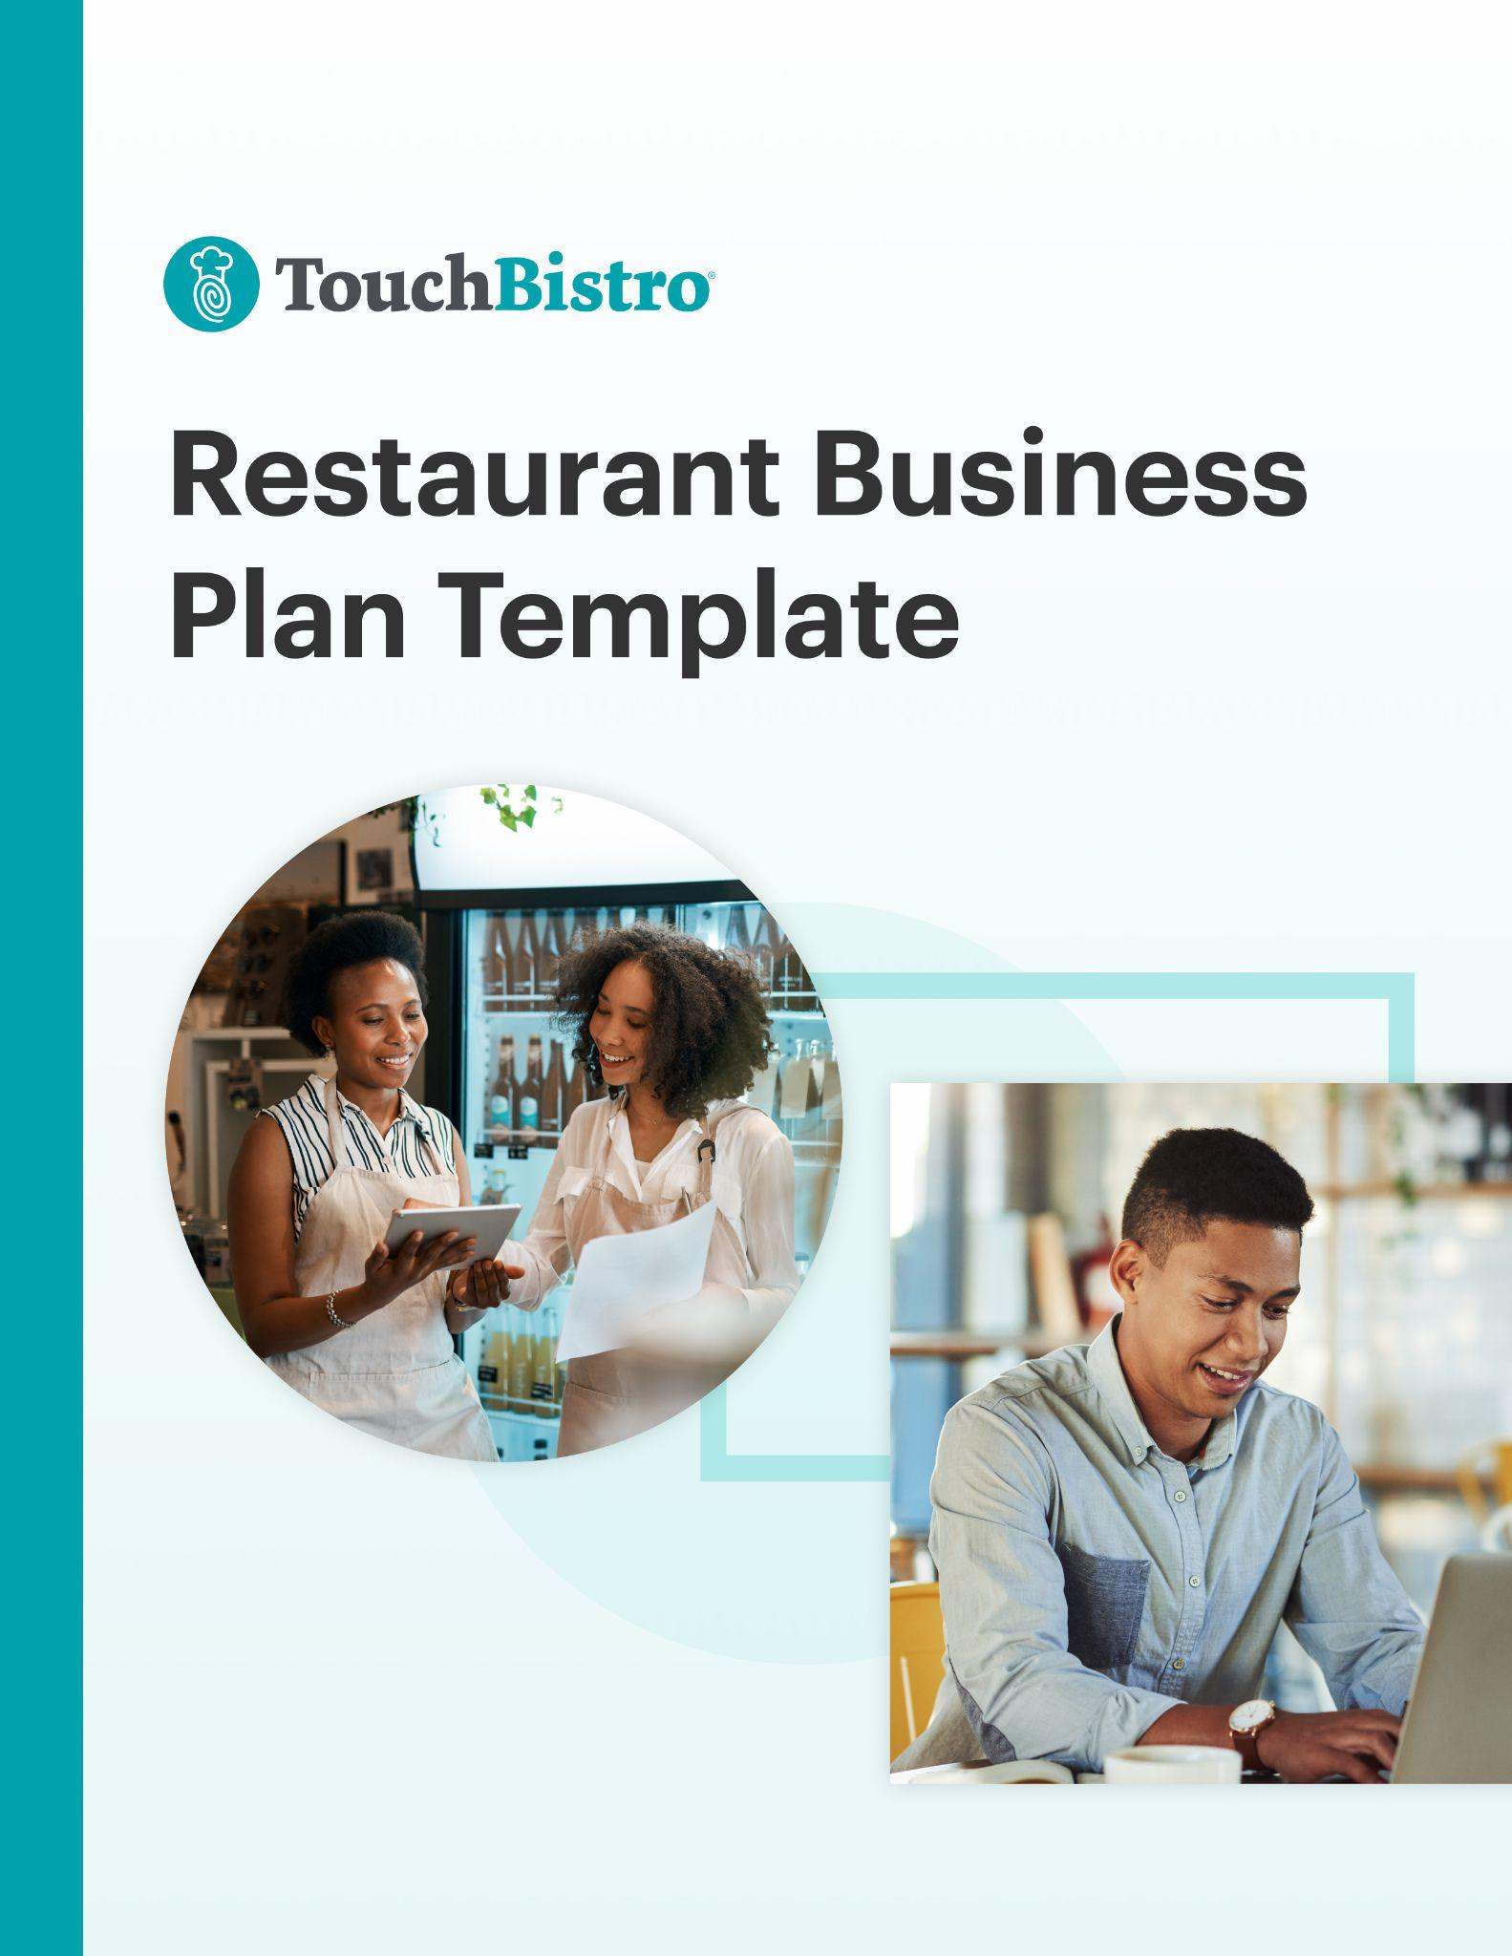

Thank you for downloading TouchBistro’s Restaurant Business Plan Template!

This restaurant business plan template will help you outline the vision for your new business and share that vision with your investors.

Instructions
This restaurant business plan is designed to be fully customized. Under each header, you’ll notice a description for the section in red italics. To customize each section, simply delete the red text and add your own information.

Once you’ve finished filling in each section, delete any remaining red text, as well as the cover page and this instructional page.

To print your template: Click File > Print
To save the template as a PDF: Click File > Save As > PDF

[YOUR COMPANY LOGO]

Business Plan for [NAME OF RESTAURANT]

ADDRESS
PHONE NUMBER
WEBSITE
EMAIL

Table of Contents

Here you’ll find the outline for each section of your restaurant business plan. You can adjust the table of contents as you customize each subsection of your business plan.

Executive Summary

Business Description

Industry Analysis

Marketing Plan

Operations Plan

Financial Analysis & Growth Plan

Appendix

Executive Summary

A business plan should always start with an executive summary. This section should summarize your main points, while also inviting the reader (often an investor) to read the rest of your business plan.

This section should also highlight key elements that will be discussed throughout the rest of your business plan, such as:
- Your restaurant’s name, concept, and type of cuisine
- Your mission statement
- Your market position and competitive advantage
- Financial projections and break-even point
- A summary of potential costs and the expected return on investments

While it may be tempting to try to include a lot of information right off the bat, try to keep this section to 200-600 words max.

Business Description

This is the section where you fully introduce your new business. The purpose of this section is to provide your reader with a high-level overview of your restaurant idea and to answer key questions that investors may have, such as the business concept, service model, and ownership structure.

As you fill out each of the sections below, keep in mind that this section can easily come across as a bit dry and mundane. Think about how you can make your business idea stand out with passionate language and captivating details.

Concept
In this section, provide a high-level overview of the concept for your new restaurant. While you don’t need to go into too many specifics here, you may want to touch on:
- The defining theme for your restaurant
- The cuisine or food you plan to offer
- What price point will you serve

Service Model
It’s important to explain what kind of service model your new restaurant will be using and why. Every restaurant is different, but here are some of the most popular service models to consider:
- Full Service: Staff provide full service to guests – from the time they arrive until the time they pay.
- Limited or Hybrid Service: Limited service falls somewhere between table service and counter service. In most cases, guests are seated by a host, but they order any food and drinks themselves from a counter. Their order is then delivered to their table by a staff member.
- Self-Service: In many fast food and fast casual concepts, self-serve kiosks allow customers to independently order and pay for their meal.
- Build-Your-Own Service: The build-your-own model is generally used in fast casual restaurants and involves an assembly line-style process where customers point to ingredients they want and staff build the order for them.

Sample Menu
Here you’ll want to include a sample menu for your restaurant, with separate menus for breakfast, lunch, dinner, and drinks (if applicable). This section should also include your strategy for menu pricing, menu design, and menu engineering.

Need help designing a sample menu? Start with one of these free menu templates.

Design & Layout
Here you should provide an overview of your restaurant design and layout. Be sure to touch on elements like staff uniforms, plateware, lighting, and more, all while explaining how each of these elements complements your brand.

Management & Ownership
This section should provide more information about yourself and the management team you’ve assembled for your new restaurant. When talking about yourself, highlight any relevant experience that will aid in your success. When talking about your team, include the names of everyone involved, their backgrounds, and their individual responsibilities.

Market Analysis

This section is where you describe the specific location of your new restaurant and the current market conditions. In addition to general information about your target market, you want to explain your unique positioning in the market, the target audience you’re hoping to appeal to, and how you’ll make your restaurant stand out.

Location
Explain the location of your new restaurant and why you chose that specific area. If you have not yet chosen a location, describe the town or neighborhood you plan to do business in.

Target Market
Describe your target market and your ideal customer profile. Include key information such as market size, demographics, characteristics, and diner behaviors.

Market Positioning & Strategy
Here you should describe how you’ll actually reach your target audience. Outline how you’ll position your brand and how you’d like it to be perceived by customers.

Competitive Analysis
In this section, you want to explain the current competitive landscape, as well as your own competitive advantage.

It’s more than likely that there are other restaurants in your area targeting the same demographics, which means you’ll need to explain how you’ll stand out from the competition. The best way to do this is to include a SWOT analysis for your restaurant that outlines your business’ strengths and weaknesses, as well as any external opportunities and threats you’d face. This will help investors better understand the specific aspects of your business that will give you a competitive advantage over similar concepts in the area.

Here is a simple example of what your SWOT analysis could look like:

Strengths:
A leadership team with a combined 35+ years of restaurant experience.

Weaknesses:
The ramp-up time for new staff could set financial projections back.

Opportunities:
Our location is located in a theater district, which would provide a steady flow of diners around dinnertime and later in the evening.

Threats:
An established restaurant that serves a similar cuisine is located in close proximity, which may take away some of our market share.

In your SWOT analysis, remember to not only identify weaknesses and threats, but also how you can overcome them. You want to reassure investors that your business will succeed despite the challenges you’ll face.

Marketing Plan

Your marketing plan section details the marketing strategy and tactics you’ll employ to get the word out about your restaurant. This section should go into detail about how you plan to market your restaurant, both before and after you open.

New to restaurant marketing? Download our Ultimate Guide to Restaurant Marketing.

Public Relations
Whether you plan to hire a PR firm or do it yourself, here is where you should detail the PR strategy for your restaurant. Include any materials you may send to newspapers and other relevant publications, such as a press release about your restaurant opening or VIP invites to the soft opening.

Advertising
Here, highlight the different advertising channels you plan to use for your restaurant. This can include digital advertising channels such as email marketing and paid search, as well as more traditional advertising tactics like flyers and radio ads.

Social Media
These days, nearly every restaurant leverages social media for marketing. Explain how you will use social media to reach your target audience, including which platforms you’ll use (i.e. Facebook, Instagram, etc.), what kind of content you’ll share, and how you’ll build a digital community around your restaurant.

Community Partnerships
No restaurant operates in a vacuum. Here you should explain any community partnerships and charitable initiatives.

Operations Plan

In this section, you need to explain how your restaurant will operate day-to-day once you’re up and running. This section should touch on key aspects of your business operations, including your staffing strategies, the technologies and equipment you plan to use, kitchen workflows, and your suppliers.

Staffing & Training
Staffing is a major hurdle for just about every restaurant. This section should break down your complete staffing strategy, including how you plan to recruit new staff and the hiring criteria for each role. You should also include details about how many people you expect to hire for each role and the approximate pay for each position.

In addition to hiring, this section should also touch on day-to-day staff management, including how you will handle scheduling, payroll, and labor reporting. You may also want to include details about staff training procedures and work safety standards for your restaurant.

Compensation Model
There are many different ways to manage, compensate, and reward restaurant staff. In this section, you’ll want to describe your compensation model and how you will manage it. Here are some common compensation models you might consider:
- Gratuity-Free: Also known as “tip-free,” the gratuity-free model is a system where servers don't accept tips. Instead, servers are paid an hourly living wage – often plus employee benefits like health insurance.
- Profit-Sharing: Also known as revenue-sharing, profit-sharing is an incentive-based system in which staff receive additional payment – in addition to regular compensation and bonuses — based on the restaurant’s profitability.
- Open Book Management: Open-book management is a system where restaurant management shares the business finances with employees. The idea is that greater transparency into the finances gives employees a better idea of how their work contributes to revenue.

Technology & Equipment
In this section, provide an overview of key technology you’ll use in your restaurant, such as your point of sale (POS) system, inventory management software, online ordering system, and more. You should also mention key pieces of restaurant equipment you plan to use, especially if you need equipment that’s not standard in most commercial kitchens.

Kitchen Layout & Workflow
Here, you’ll want to provide an overview of your kitchen layout and what the workflow will be like for staff. If you have a floor plan of your kitchen or other visual aids, you can include them here and/or attach them in the appendix.

Inventory & Suppliers
Related to your back of house layout are the kitchen processes you plan to adhere to, such as food cost control methods and food inventory suppliers. Provide an overview of the type of vendors you’ll use and how you’ll manage inventory and food costs. If applicable, include a cost analysis of various food vendors.

Financial Analysis & Growth Plan

Though your financial analysis is one of the last sections of your business plan, it’s also one of the most important sections. In fact, many investors may skip straight to this section to see a breakdown of your anticipated costs and projected revenue, as well as how you plan to spend their investment.

Before finalizing this section, triple-check your projections and considering hiring a financial professional to make sure your numbers are sound.

Startup Costs
In this section, you’ll need to disclose how much money you’ll need to get your business off the ground, including your biggest expenses.

Financing & Loans
Most restaurateurs require loans or other sources of funding to get up and running. In this section, detail the types of financing or loans you require to fuel your growth.

Investment Plan
Here, explain the initial investment you are hoping to receive and how you plan to spend it during your first year in business.

Sales Forecast
Your sales forecast should highlight your projected weekly, monthly, and/or annual first-year sales projections. To get this number, you may use different criteria, such as capacity limits, table turn rates, delivery and/or takeout options, menu prices, and more.

Projected Profit & Loss Statement
Use a projected (or pro forma) P&L statement to show how much money you expect to have made (or lost) by the end of your first year in business. This figure should be based on your sales forecast, as well as your projected restaurant costs.

Break-Even Analysis
A break-even calculation reveals the amount of revenue needed in order for your restaurant to make a profit. You can then compare this number to your sales forecast to determine how long it will take for you to break even so you can let your investors know when they can expect to start seeing an ROI.

Expected Cash Flow
Cash flow is the amount of cash that’s coming in, and going out of your business. For a restaurant, this figure will vary based on how often you expect to purchase inventory, the size of your staff, your payroll schedule, and various other factors. In this section, you want to detail your expected cash inflows and outflows for an upcoming period (usually a year).

Appendix

Last but not least is your appendix. While this section is optional, it’s a great place to include charts, plans, graphics, pictures, or any other material investors may find useful. In your appendix, you may want to include:
- A sample menu
- Floor plans for your dining room and/or kitchen
- Additional financial charts and figures
- Design mockups

